- AIM: To Create a simple cloud software application for Flight Reservation System using any Cloud
Service Provider to demonstrate SaaS include the necessary fields such as one way, round
trip, From, to, Departure, Departure, Travelers &amp; Class, Fare Type, International and
Domestic Flights etc.
Output:
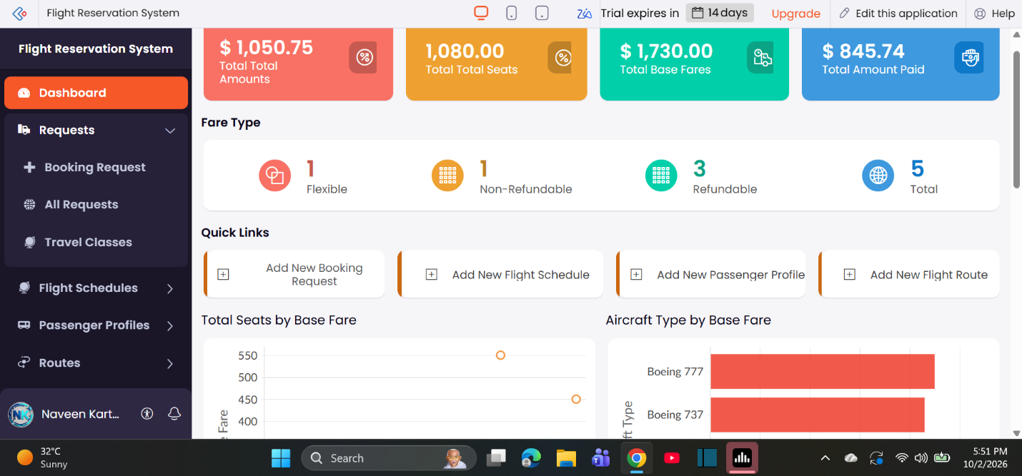

- AIM: To Create a simple cloud software application for Property Buying &amp; Rental process (In Chennai
city) using any Cloud Service Provider to demonstrate SaaS include the necessary fields such
as Buy, Rent, commercial, Rental Agreement , Rental Agreement, Area, place, Range,
property value etc.
Output: 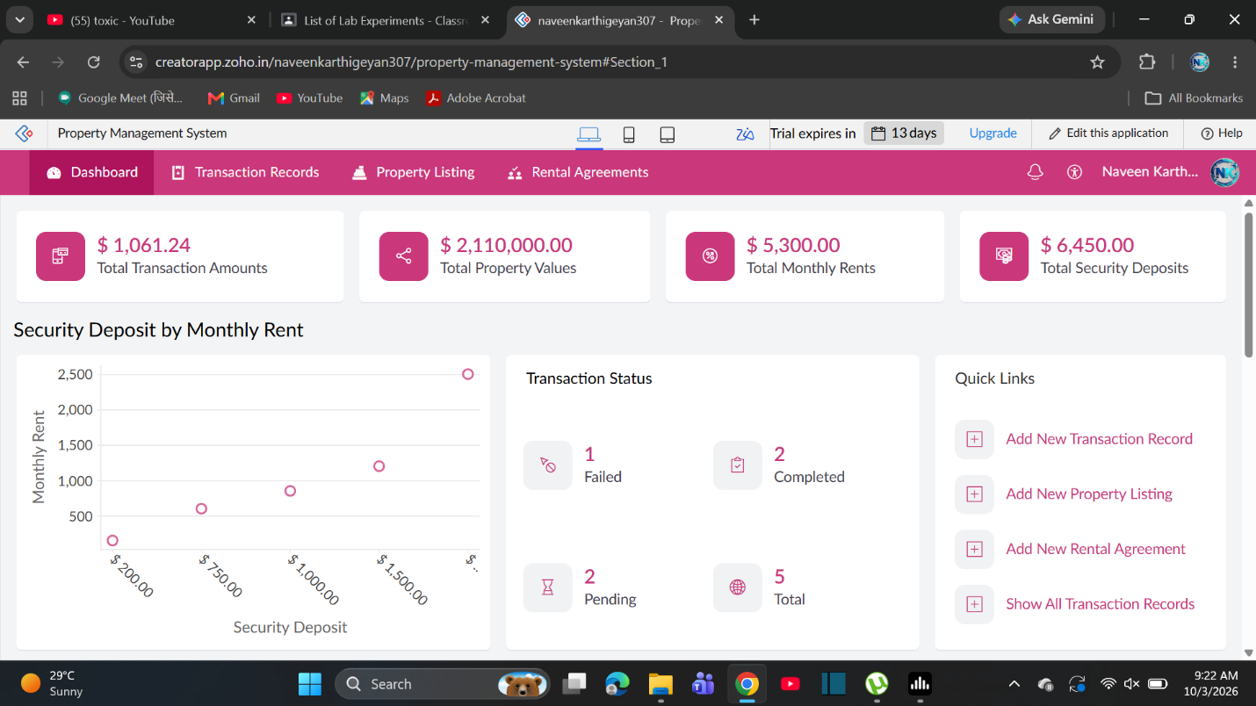

- AIM: To Create a simple cloud software application for Car Booking Reservation System using any
Cloud Service Provider to demonstrate SaaS include the necessary fields such as search for
cabs, from, to, rental , out station, Package type, hours/Days etc.
Output: 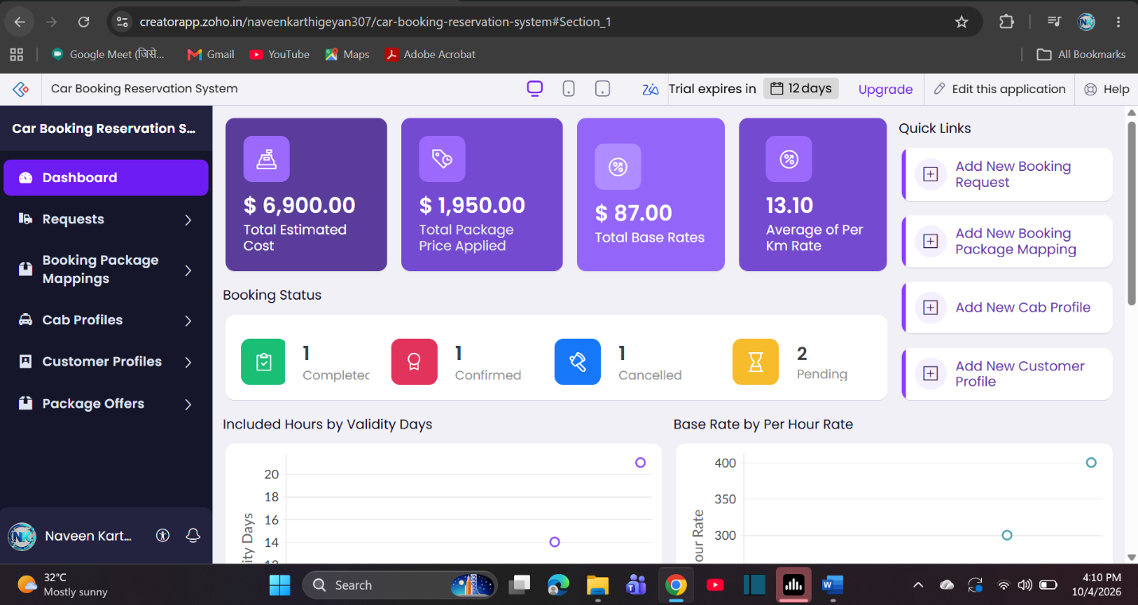

- AIM: To Create a simple cloud software application for Library book reservation system for SIMATS
library using any Cloud Service Provider to demonstrate SaaS include the necessary fields
such as Title of the book, author, publications, Year, edition, no of copies, Rack no, status
(taken/returned) etc.
Output: 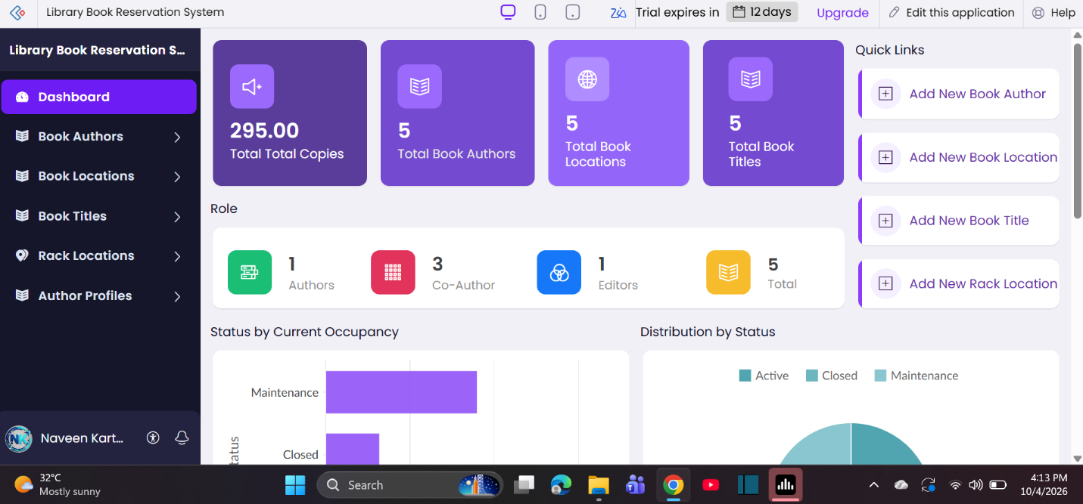
- AIM: To Create a simple cloud software application for Mark Sheet Processing System using any
Cloud Service Provider to demonstrate SaaS include the necessary fields such as name of the
student, Reg no of the student , Subjects , Marks, Average, percentage, rank, overall
performance etc.
Output: 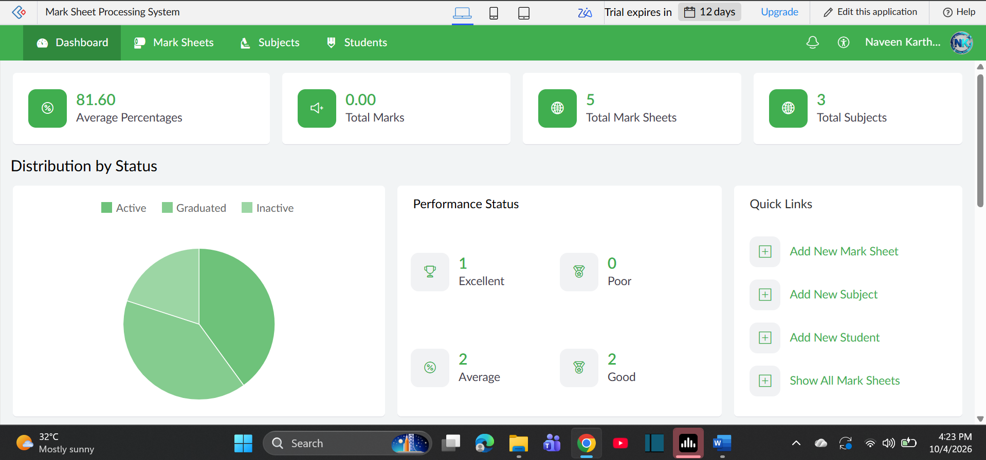

- AIM: To Create a simple cloud software application for Payroll Processing System using any Cloud
Service Provider to demonstrate SaaS include the necessary fields such as Name of the
employee, experience in present org , over all experience, basic pay, HRA, DA, TA, net pay,
gross pay etc.
Output: 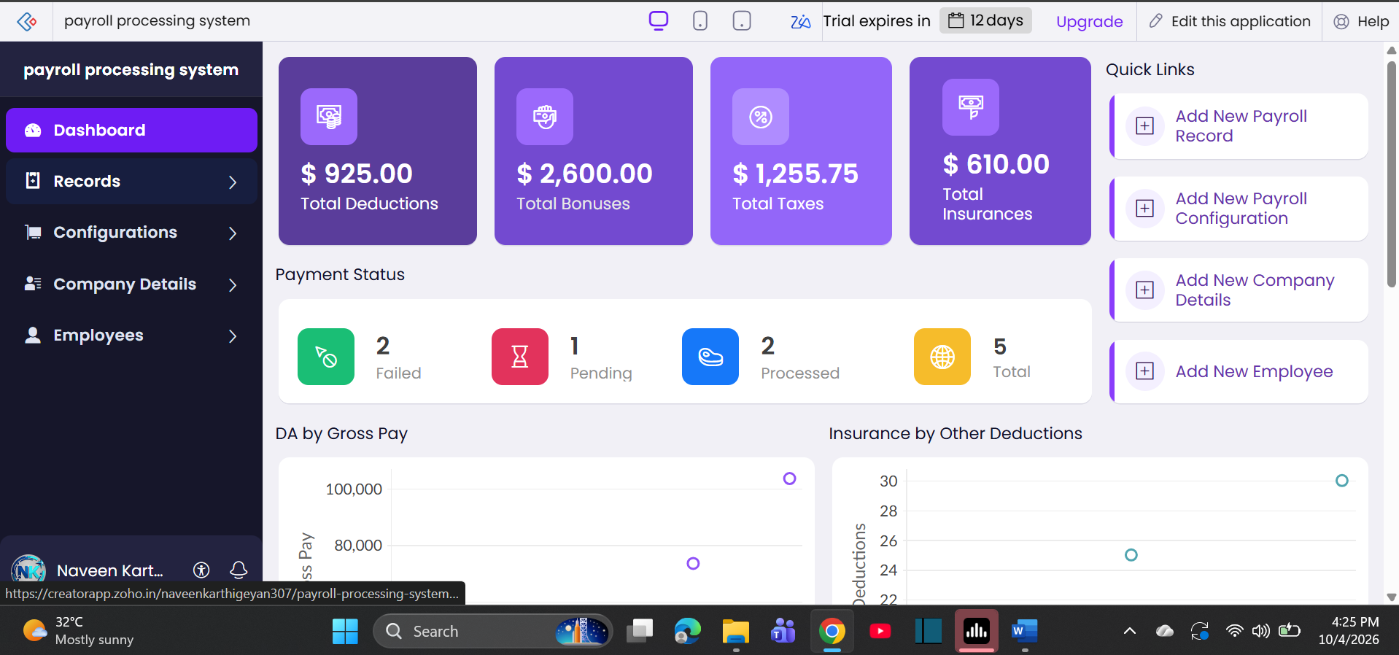

- AIM: To Create a simple cloud software application for Students Attendance System using any Cloud
Service Provider to demonstrate SaaS include the necessary fields such as name of the
students, course, present , Absent, course attendance, OD request, grade, attendance
percentage, etc.
Output: 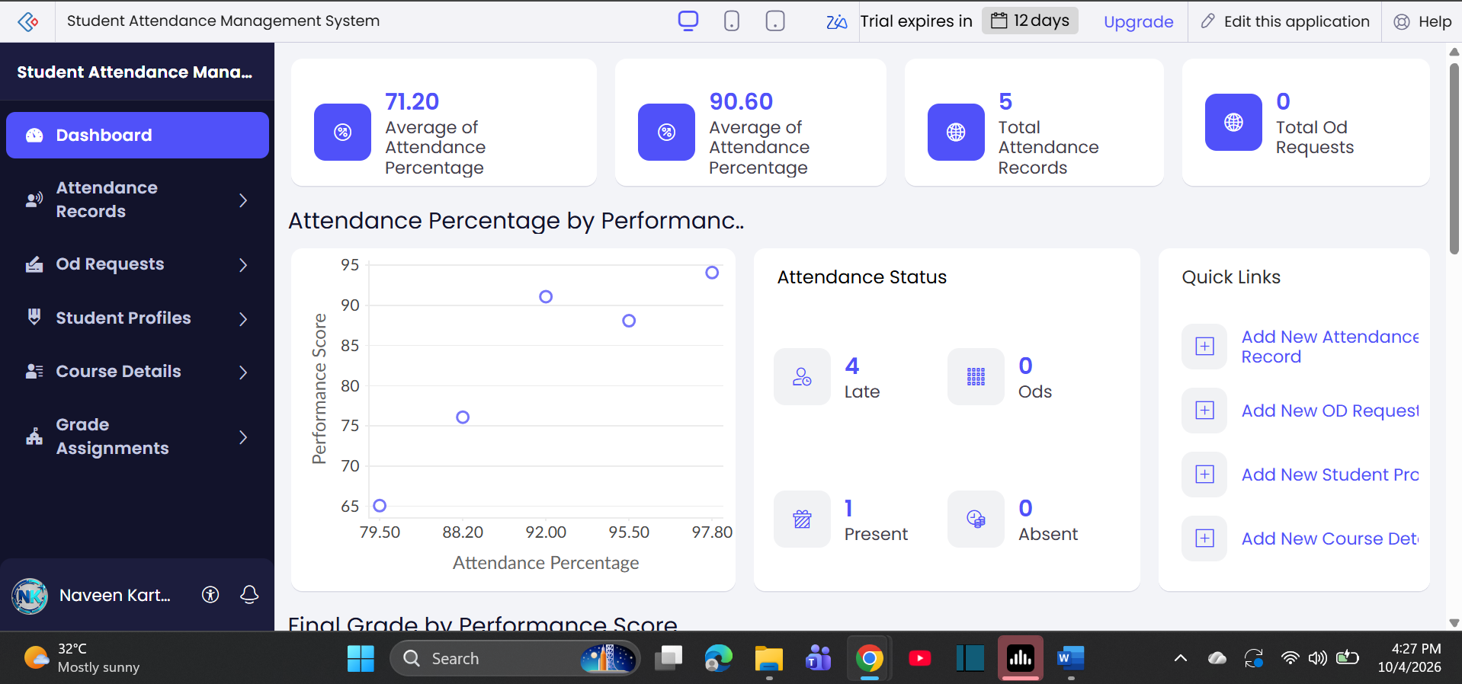

- AIM: Create a simple cloud web application for student counselling system using any Cloud
Service Provider to demonstrate SaaS with the fields of student name, age, address, phone,
subjects studied, Year of passing, percentage of marks, domain interest, etc.
Output: 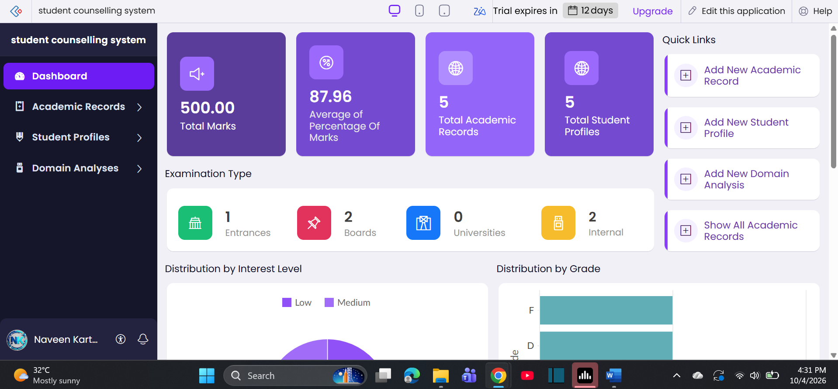

- AIM: To Create a simple cloud software application for Hospital information system for SIMATS
Hospital using any Cloud Service Provider to demonstrate SaaS with fields of patient name,
age, address, phone, email, Attender name, attender phone, doctor name, diseases, etc.
Output: 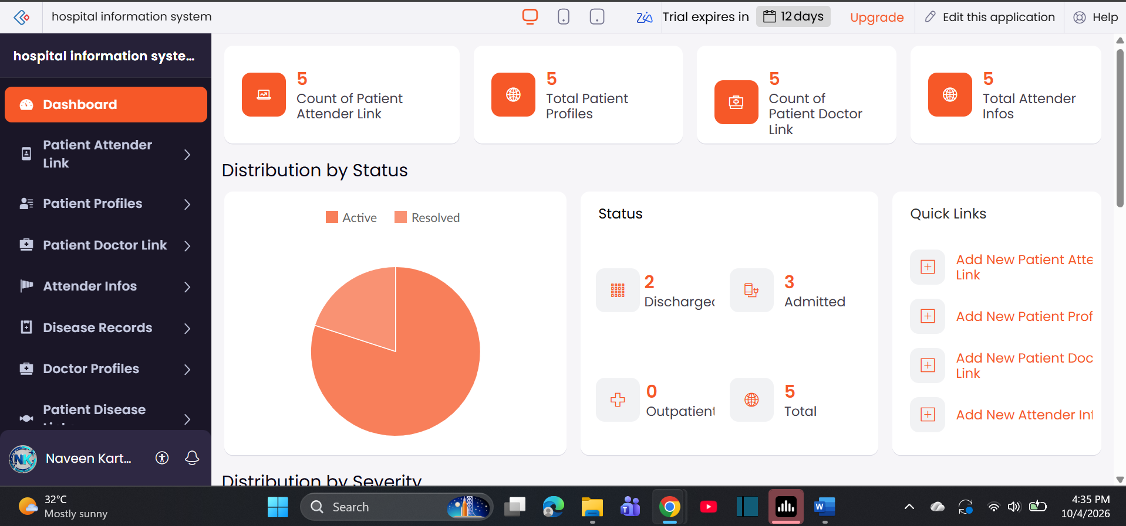
- AIM: Create a simple cloud software application to run a c program to display the student
information using any Cloud Service Provider to demonstrate SaaS with the template of
student name, reg no, address, phone, age, courses, grades and attendance report, progress
report, Semester mark sheet forms
Output: 